
Faculty of Engineering and Technology

Department of Electrical Engineering/ Communication and Computer
Computer Networks Lab
Packet Tracer (Home Work #2)
name : mousa mohammed noor mousa ayyad
ID :202412550

Using Packet Tracer, do the following topology:
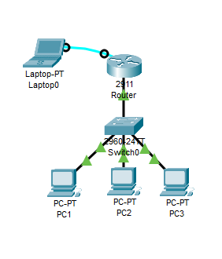
Given that you have the IP 192.168.10.0/24 do the following
Build the above topology
- Give router a host name and MOTD.
- Configure to remote telnet login on the router
The First user is “Your name” and the second user "admin". Use the same password for both connections "321"
- Configure the console login to have the password "654321"
- Configure the Interface of the router as default gateway.
- Configure a DHCP server on router with pool named “PCs”. The network should be from the family 192.168.10.0 and the DNS is 8.8.8.8
- Configure PC’s to have dynamic IP's

Save all your works

Task 1:
- Insert Screenshot for Your topology

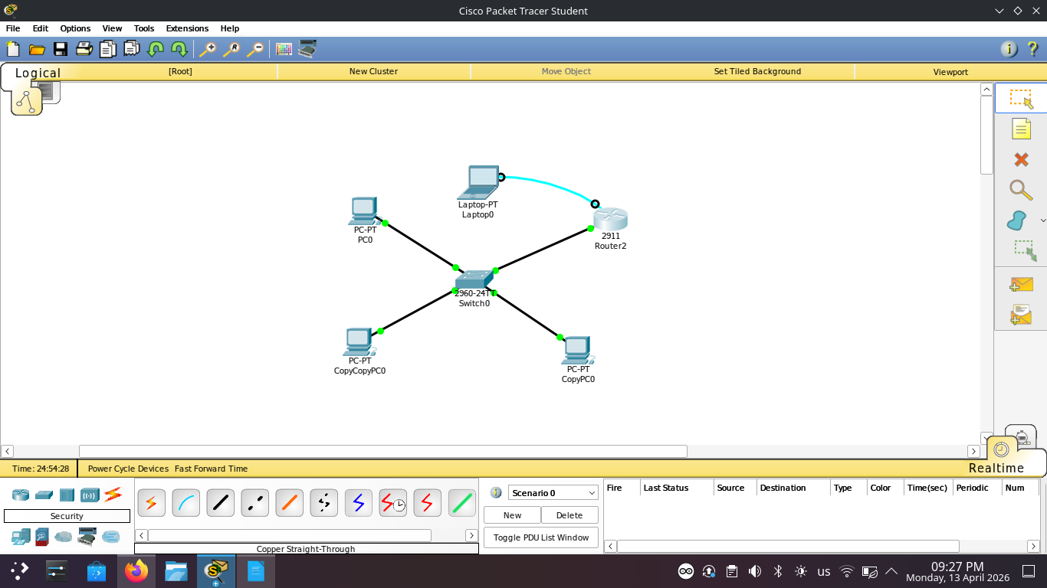

Task 2:
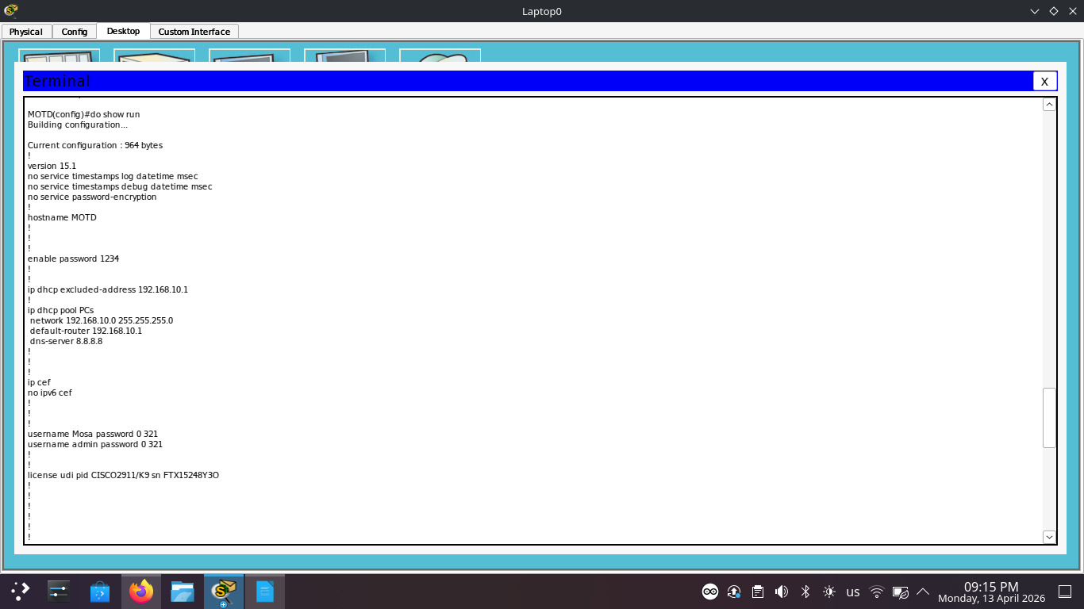
- Check DHCP server (show running-config)

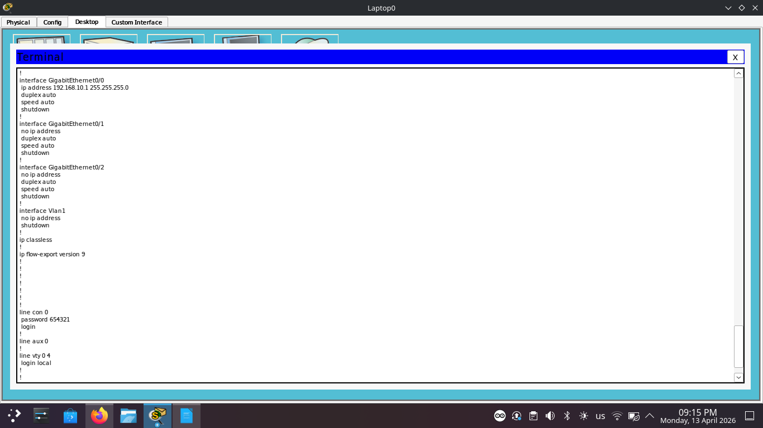

Task 3:
- Check Router remote telnet login (from PC1 (cmd))

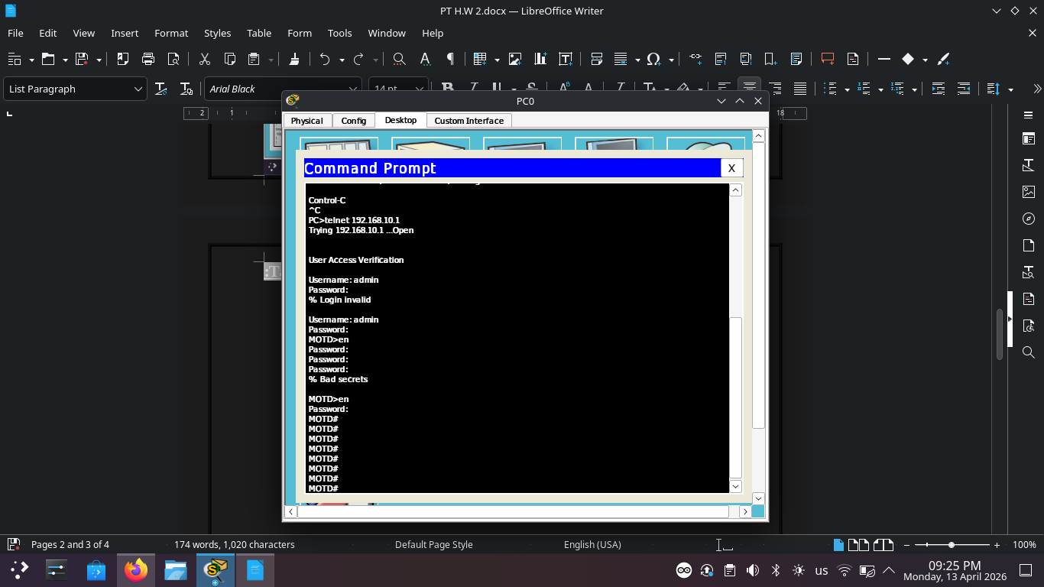

Task 4:
- Ping from PC1 to PC3 (Cmd)

